HAMAV
High Altitude Micro Air Vehicle
Graphical Content
Jan Struziński, Chief Engineer, 3SAT
Mateusz Mazurkiewicz, Team Leader, 3SAT
Łukasz Gałecki, 3D Printing Expert, 3SAT

Table of figures:
Photography 1 - two out of three HAMAV constructors along with supporters of the project 3
Photography 2 - Zephyr, High Altitude Platform developed by Airbus 3
Photography 3 - draft of HAMAV 3
Photography 4 - soldering Li-Ion cells 4
Photography 5 - heating system 5
Photography 6 - process of modification of ariframe 5
Photography 7 - testing servomechanisms in dry ice in order to simulate stratosphere's temperature 5
Photography 8 - release mechanism and 3D printed stabilizer at the back of HAMAV 6
Photography 9 - TRA02 air zone, in which stratospheric flight was conducted 7
Photography 10 - working prototype 8
Photography 11 - astrobiological payload after stratospheric flight 9
Photography 12 - made by HAMAV in the stratosphere 9
Photography 13 - ground station 9

Render 1 - releasing mechanism 6
Render 2 - 3D printed stabilizer 6
Render 3 - experimental cargo holding bay 7

Scheme 1 - electric circuit 4
Scheme 2 - procedure 7

Simulation 1 - flight of HAMAV obtained from data logs 9

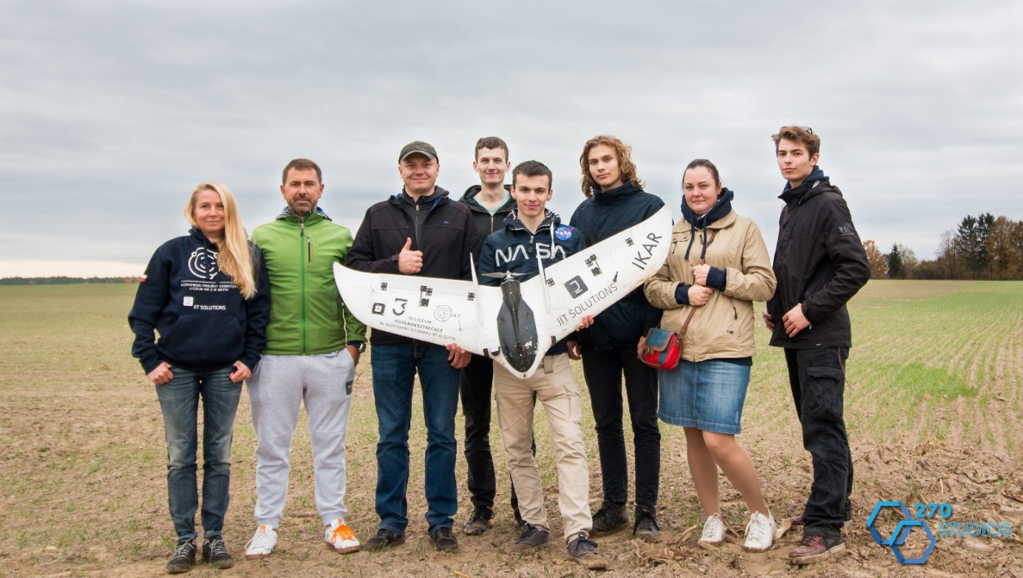
Photography 1 - two out of three HAMAV constructors along with supporters of the project
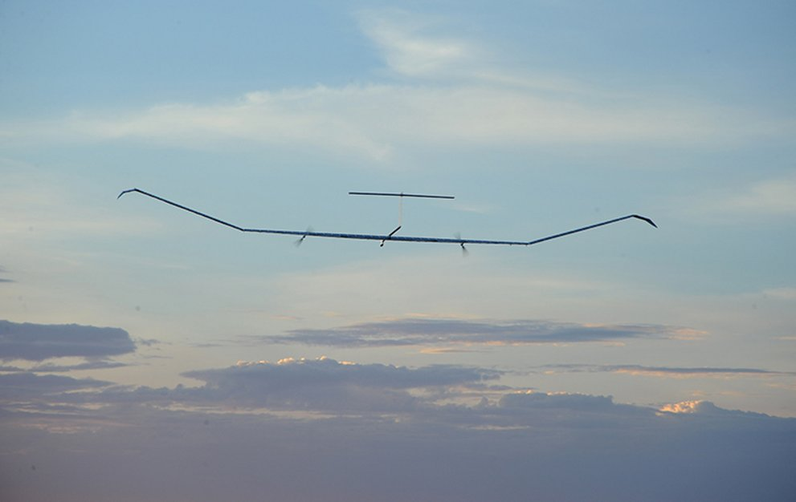
Photography 2 - Zephyr, High Altitude Platform developed by Airbus |Downloaded from: https://www.airbus.com/search.image.html?tags=products-and-solutions%3Aunmanned-air-systems%2Fzephyr&tagLogicChoice=OR#searchresult-image-all-10
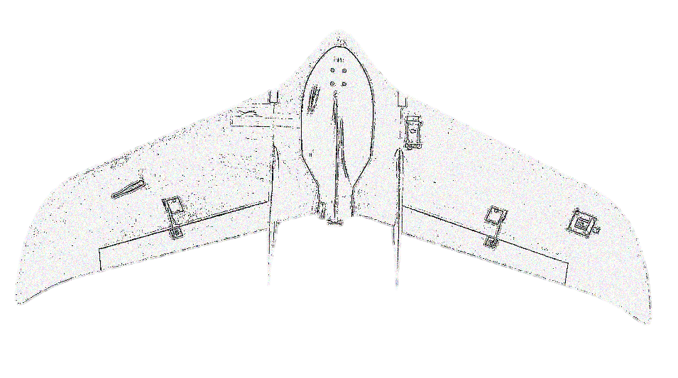
Photography 3 - draft of HAMAV

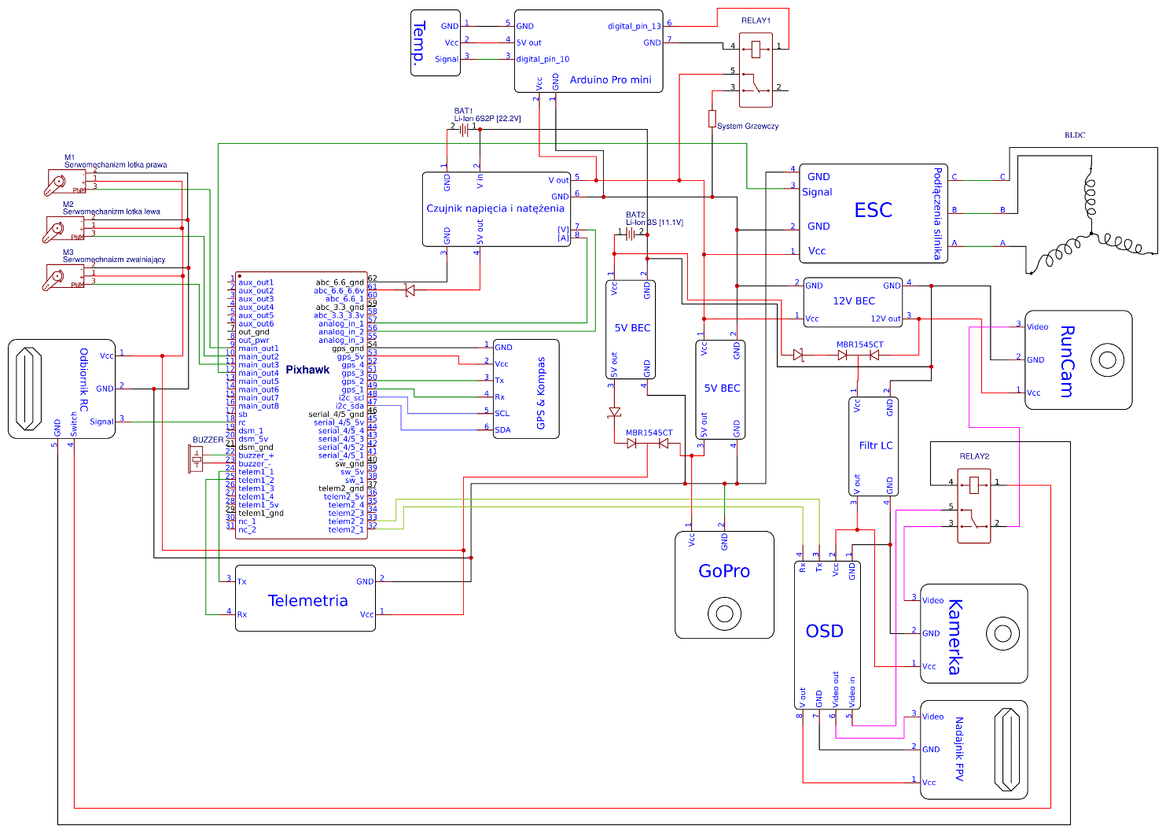
Scheme 1 - electric circuit

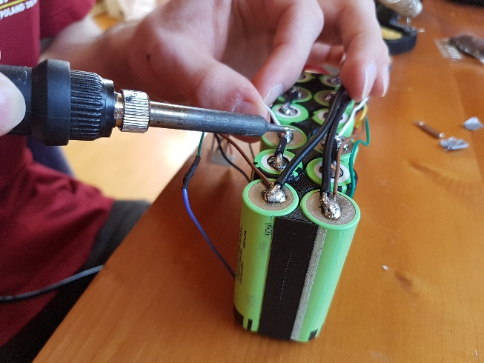
Photography 4 - soldering Li-Ion cells
Photography 5 - heating system
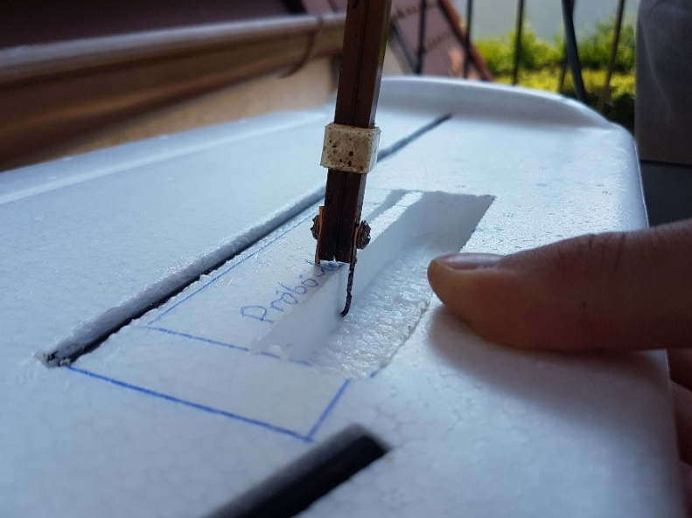
Photography 6 - process of modification of ariframe
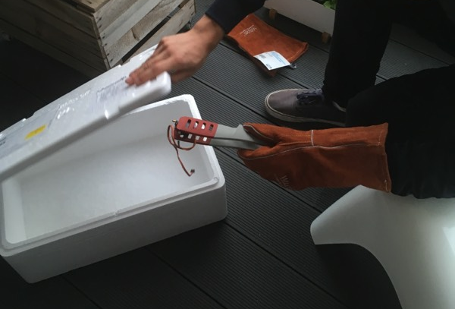
Photography 7 - testing servomechanisms in dry ice in order to simulate stratosphere's temperature
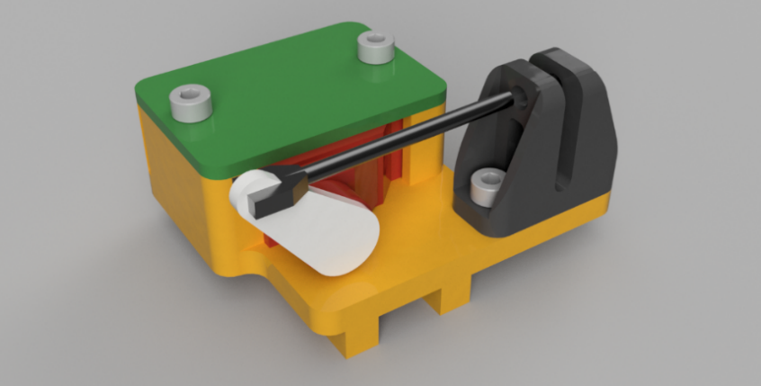
Render 1 - releasing mechanism
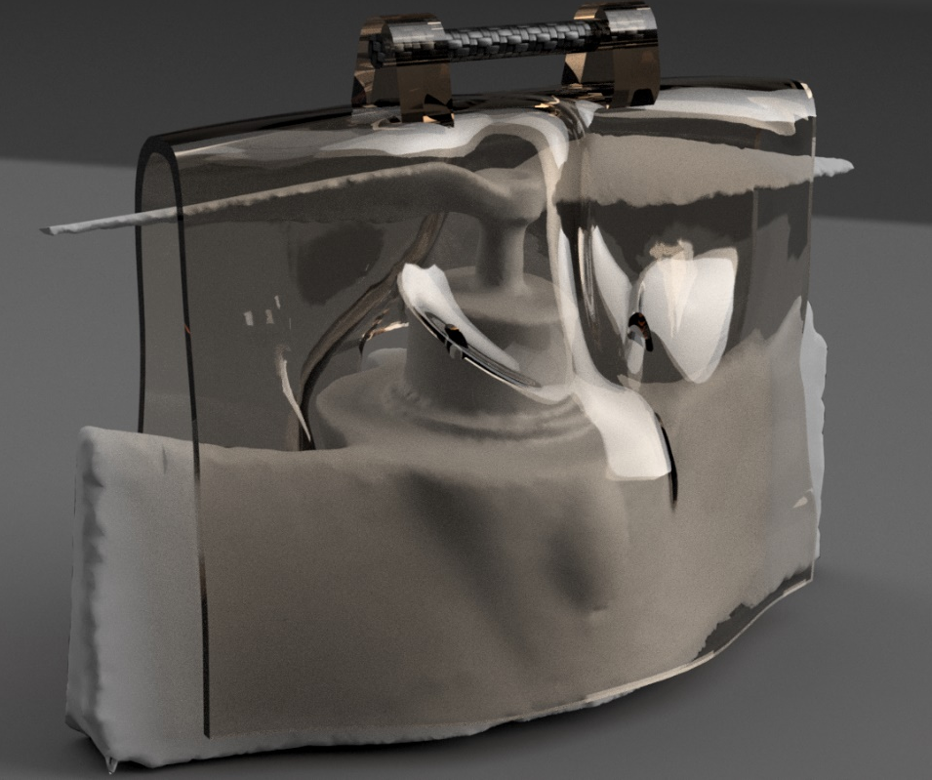
Render 2 - 3D printed stabilizer
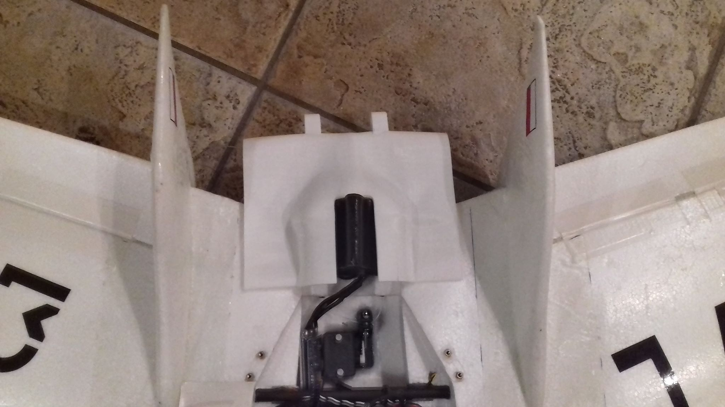
Photography 8 - release mechanism and 3D printed stabilizer at the back of HAMAV
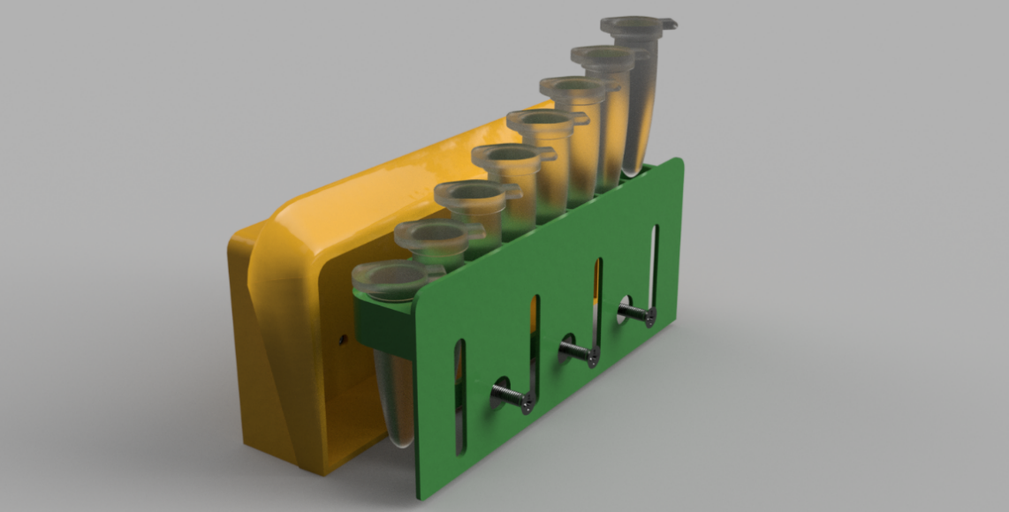
Render 3 - experimental cargo holding bay
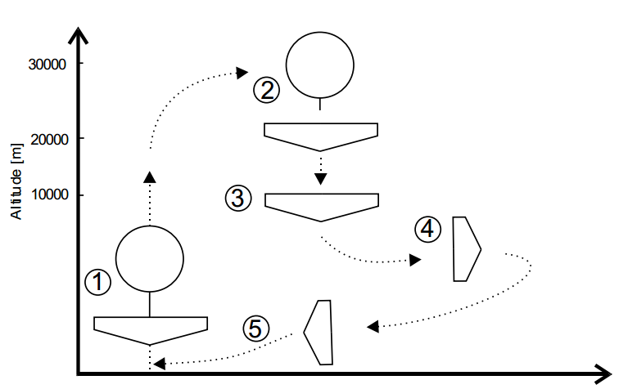
Scheme 2 - procedure; 1. ascension on the balloon; 2. release; 3. free fall; 4. gliding; 5. Landing
Photography 9 - TRA02 air zone, in which stratospheric flight was conducted
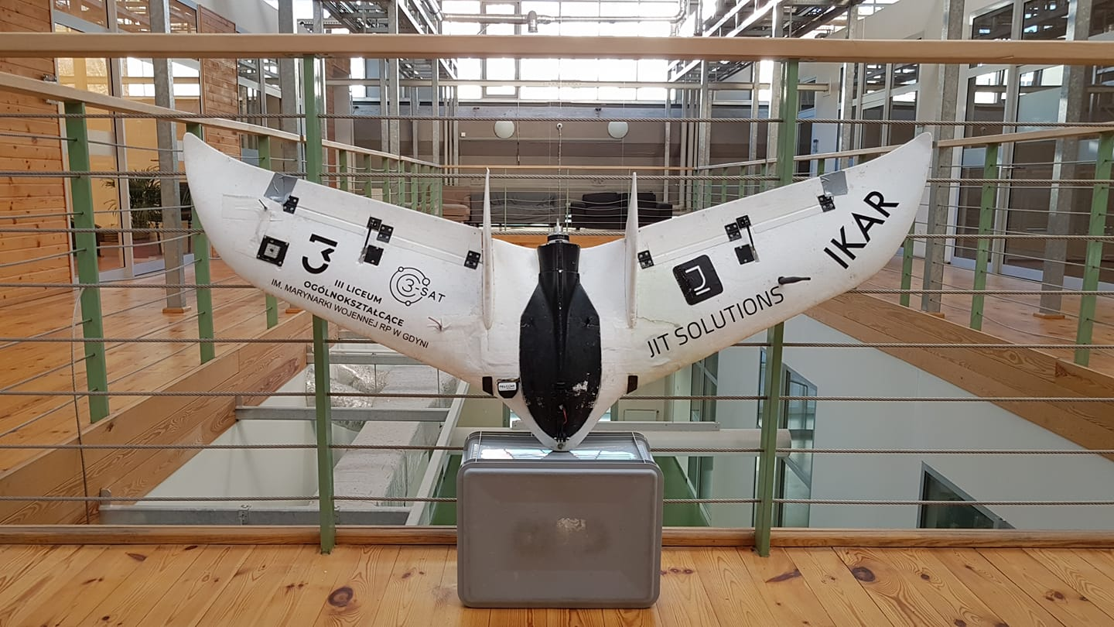
Photography 10 - working prototype
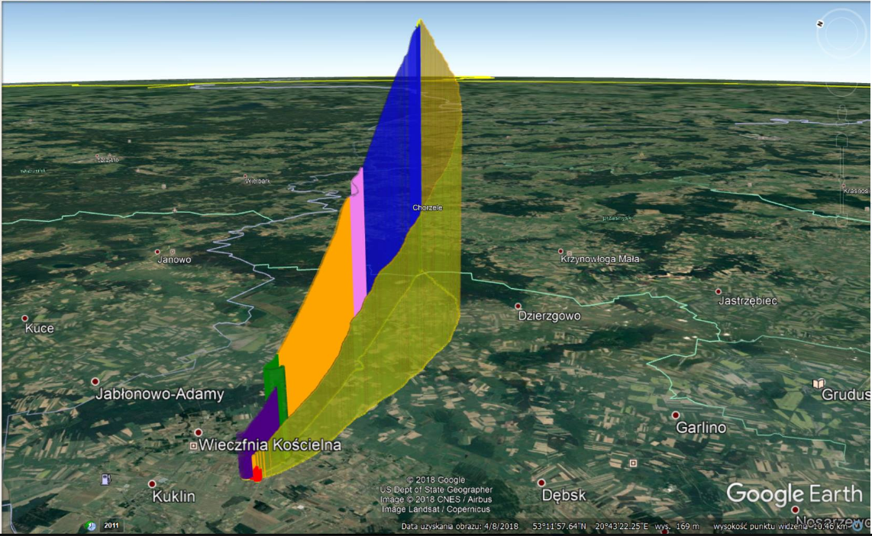
Simulation 1 - flight of HAMAV obtained from data logs

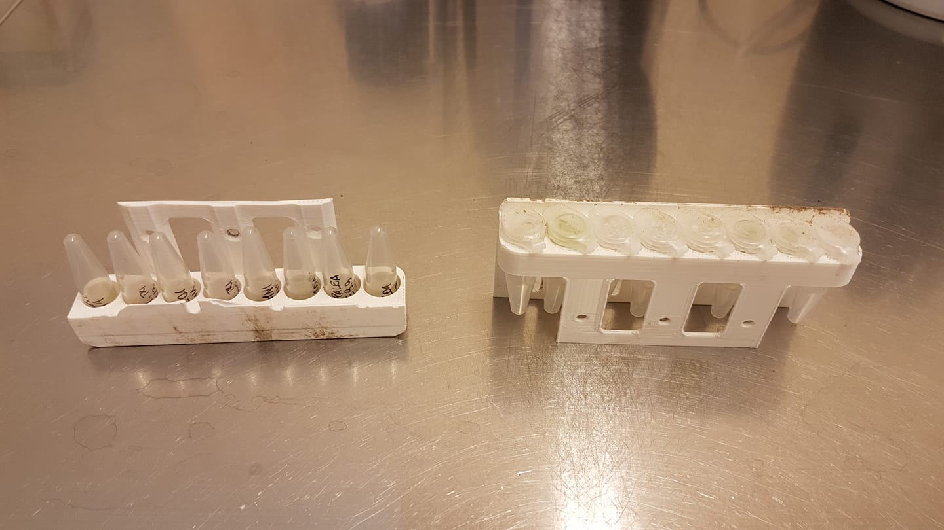
Photography 11 - astrobiological payload after stratospheric flight
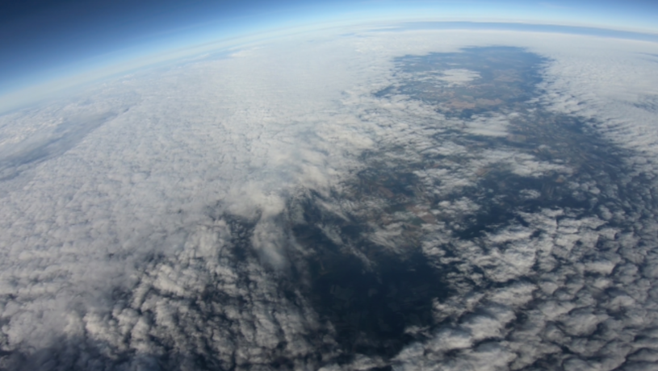
Photography 12 - made by HAMAV in the stratosphere
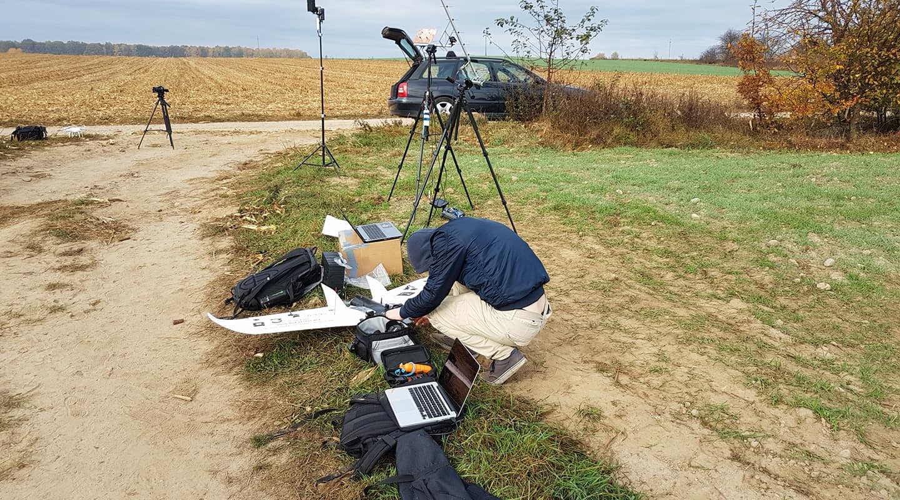
Photography 13 - ground station

