3Class System Documentation
This software enables volunteers to collaborate with students in need of tutoring from certain subjects. It was created as a service to help people stay educated during the COVID-19 issue in Poland. Teachers can monitor the progress of students, view the timetable of volunteers and encourage new students to sign up by using customisable forms. The site features mobile and PC support, a nice easy-to-use interface and good security.
Website Link: https://3class.new-cyb.org
Screenshots:
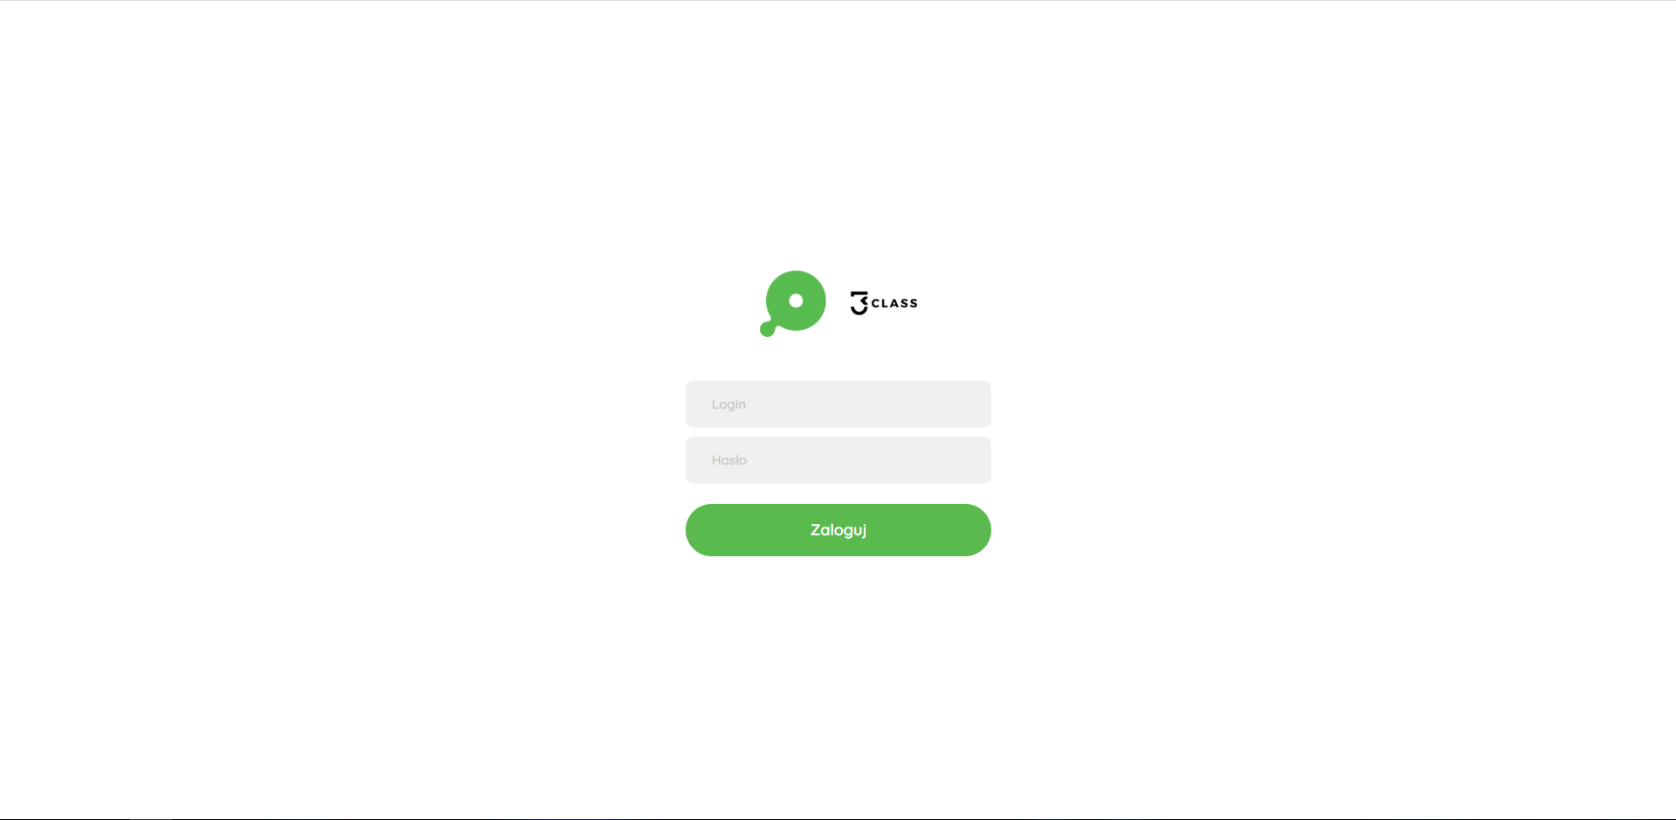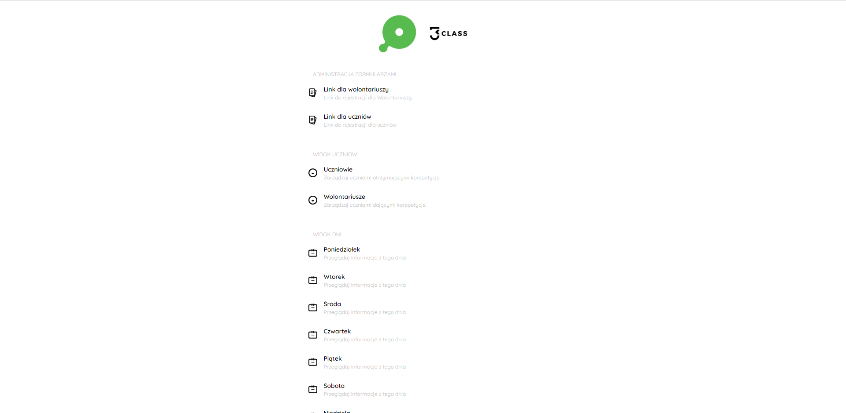
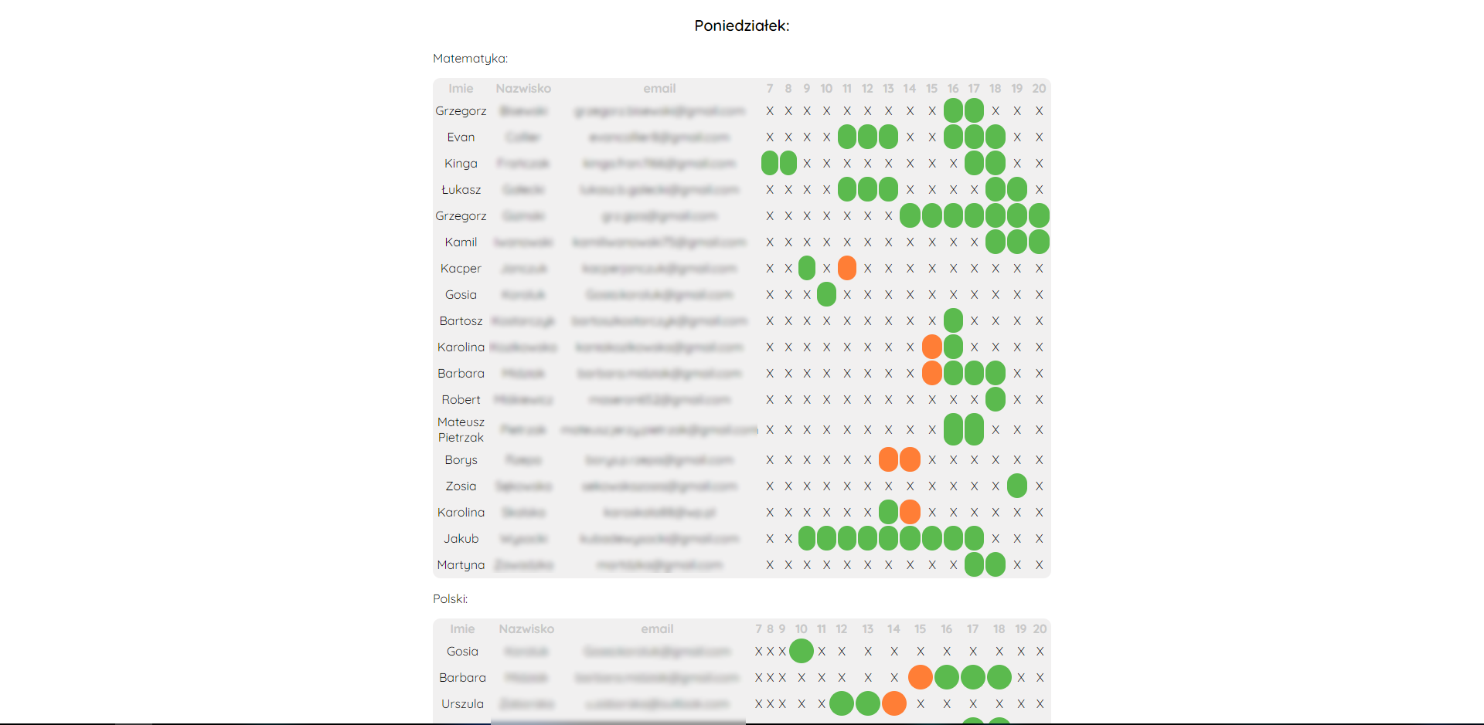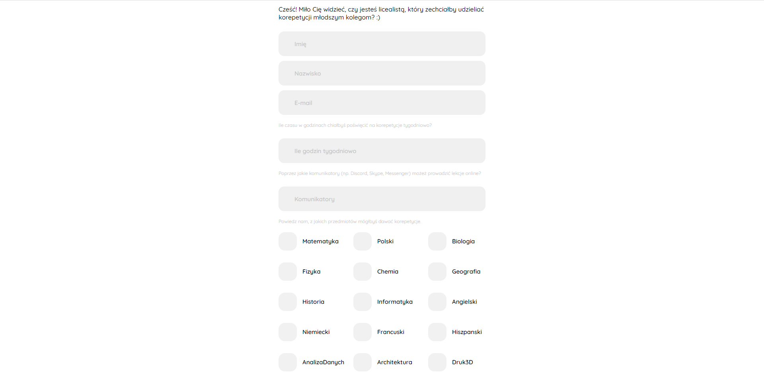
We were limited by the short amount of time that we had due to the rapidly growing number of cases of COVID-19 in Poland. The situation needed an instant solution that we created in less than 24 hours.
The main purpose of the software is to help coordinators manage online lessons during this school break, which would allow the spread of our idea: High Schools helping Elementary Schools, and help limit the spread of the virus.
We wrote our site mainly in PHP, HTML and CSS, but the skills of Matusz in making awesome icons give the site a special look and polish. Some complicated systems for managing data allowed us to create many useful tools for the coordinators, to shorten their time spent on administration. This system allows them to assign lessons to a volunteer and the website automatically updating the available time of a volunteer and give an insight of lessons timetable.

